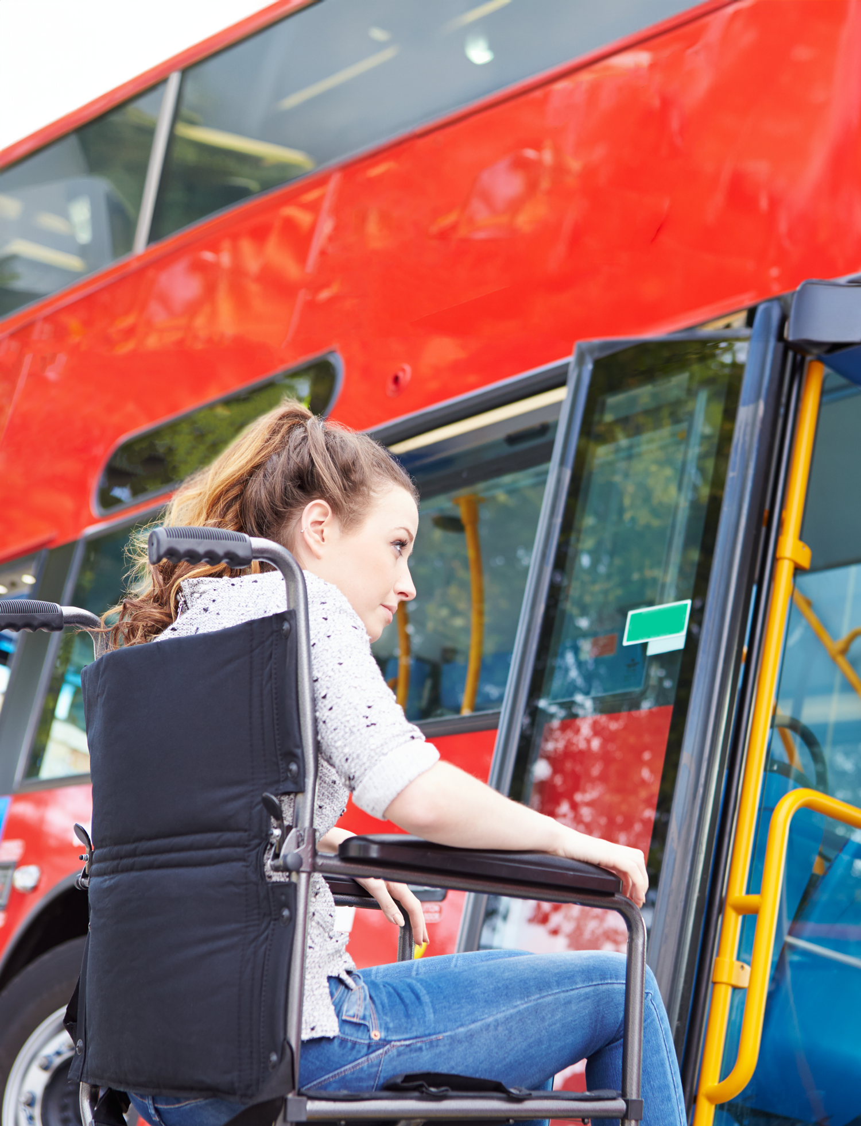
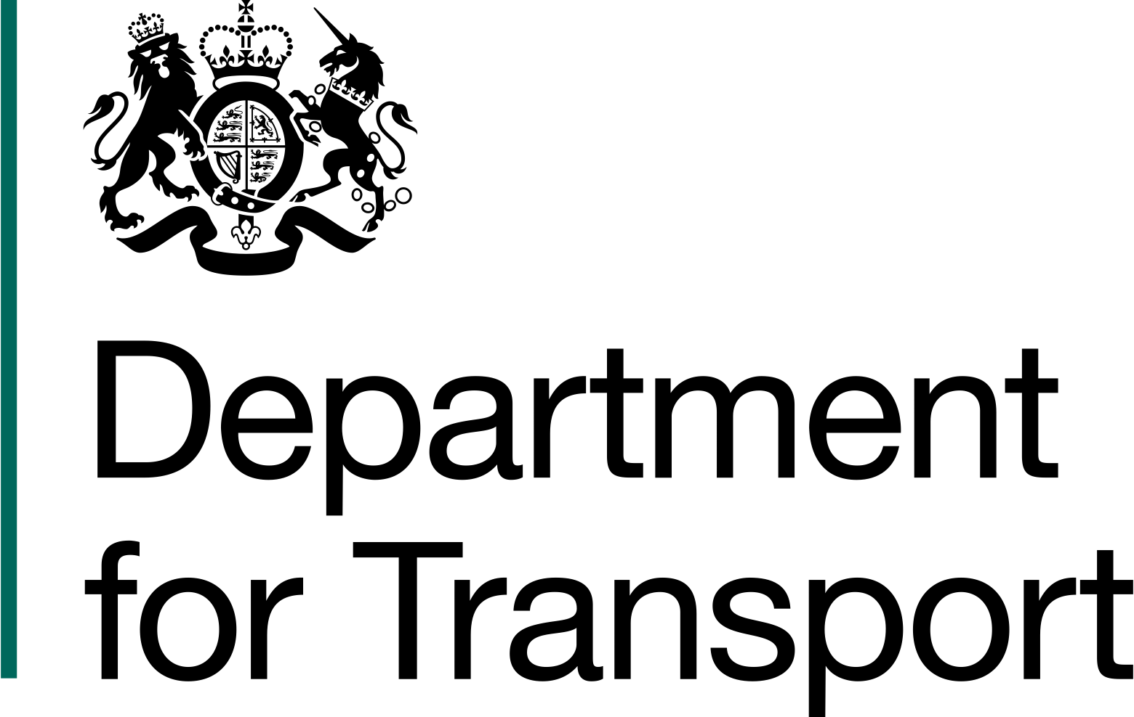
Right to Ride
  - A guide for disabled people travelling on buses, coaches, taxis, private hire vehicles (PHV), rail and light rail


Foreword - Guy Opperman MP
As a Parliamentary Under Secretary of State at the Department for Transport, accessibility is one my most important responsibilities. I am especially proud to be the Ministerial Disability Champion (MDC) for the Department, driving forward improvements to transport accessibility and inclusion.
Transport is something that many people take granted. It enables us to access employment and education, to connect with friends and family, and to use leisure and retail services. That is why this Government is committed to ensuring equal access to transport for disabled people, recognising both visible and less visible conditions. We believe that everyone should have the same access to transport and that disabled people should feel confident that they are able to travel easily and without extra cost.
It goes without saying that we cannot improve transport accessibility alone. It is essential that we work with charities like Scope, as well as industry, to achieve our ambition of creating a transport system offering equal access for disabled people by 2030. This guide is a step forward towards that goal, and I am grateful to Scope for working so positively with the Department to produce it.
This guide organises transport information across a wide range of sources into one convenient document. It provides disabled passengers with access to clear information about how to pursue their rights across all land transport modes – rail, road, bus and coach, taxis, and Private Hire Vehicles. The guide sets out the assistance that passengers must and should receive, how to complain if something goes wrong and how to claim compensation, if appropriate. It will be especially helpful for disabled people and others with reduced mobility, should elements of their journey unfortunately go wrong.
After 70 years of helping people and campaigning relentlessly to create a fairer society, Scope built on a recommendation in their 2019 ‘Travel Fair’ report to create an opportunity for us to work together and produce a resource that will benefit everyone who uses transport. I’m proud of the outcome.
Thank you for your ongoing support.

Contents

Foreword 2
Introduction 4
Rail 8
London Underground 11
Light Rail (including metros and trams) 13
Bus and Coach 16
Taxi and Private Hire Vehicle (PHV) 20
Further Information 23
Glossary 24
Annex A – Complaints process 26



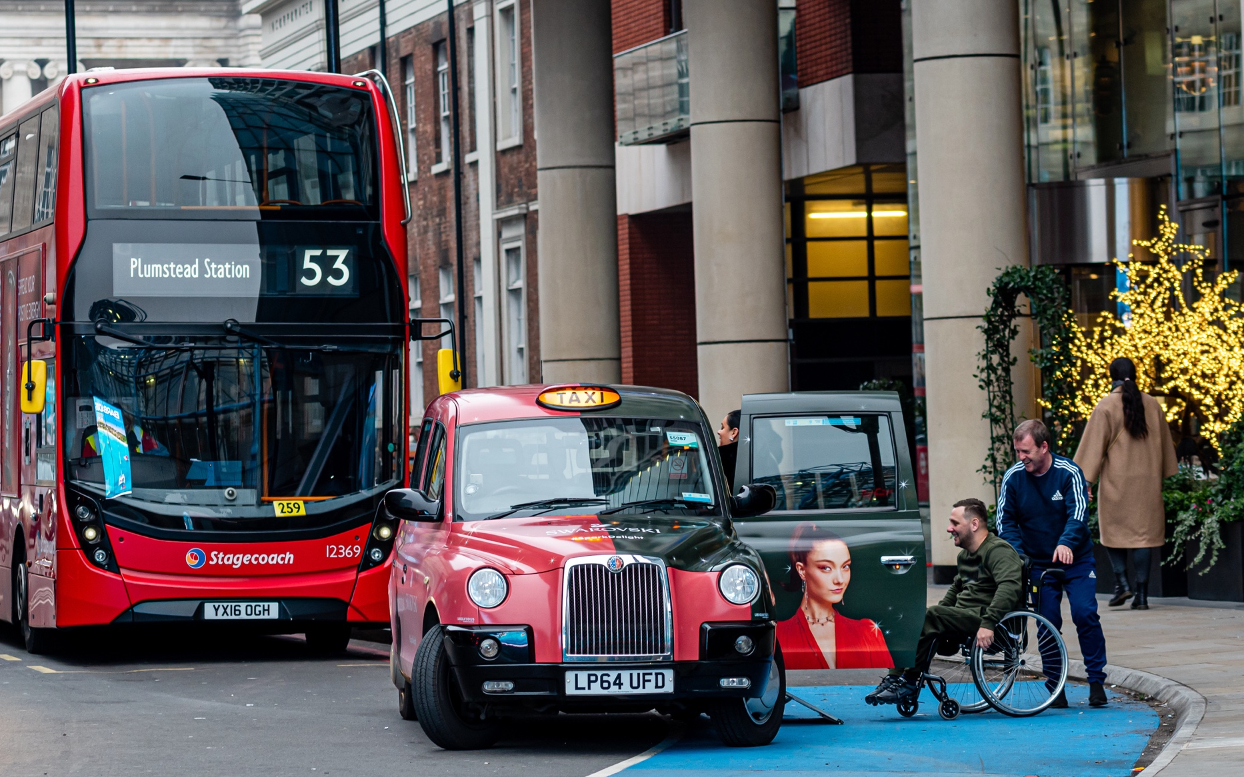
Introduction
Transport is at the heart of how we live our lives. It can act as a powerful enabler, connecting people with places, unlocking access to education and employment, but it can only do this if it is designed and provided with disabled people in mind.
The Department for Transport set out its priorities for improving access for disabled people in the 2018 Inclusive Transport Strategy (ITS) which includes the promotion of passenger rights and enforcement, better staff training and improved information across all modes of transport.
Despite this ambition, there are times when things go wrong. Scope, working with the Department for Transport, have created this guide to help disabled people and others with reduced mobility find the information you need to sort things out when this happens.
In this guide, which covers land-based public transport including trains, buses, and taxis, we set out the rights and standards that the law says you should expect, to help you understand what you are entitled to.
This guide is up to date as of 1 February 2024.

What is this guide?
Transport operators work proactively to make their services meet a range of needs; however, there may be occasions when things go wrong. In these circumstances it might not always be clear how you can get help or complain, especially when information is split across many different sources.
This guide will help you understand your options for escalating any issues that you may experience when travelling on public transport as a disabled person. It aims to:
- bring together information in one place
- help you to understand your rights across the transport network
- set out the standards you should expect when travelling, and how you can complain if things go wrong

What do we mean by ‘’you’’?
Whilst there are lots of different definitions of disability, the rights and protections covered in this guide are based on the Equality Act 2010.
You are disabled under the Equality Act 2010 if you have a physical or mental impairment that has a ‘substantial’ and ‘long-term’ negative effect on your ability to do normal daily activities. Passengers are only protected under the Equality Act 2010 if they meet this definition.

How do I use this guide?
This guide covers all land-based transport modes that operate in Great Britain. It sets out the rights of a disabled person when travelling by train, bus, coach, taxi, or a private hire vehicle. It also provides information on accessibility, how to request assistance and how to make a complaint if you believe that you have been disadvantaged by your experience as a disabled passenger.
Information is broken down into sections covering each transport mode, with the following covered in each section:
- What can I expect in terms of assistance?
- What can I expect in terms of accessibility?
- How do I make a complaint if my travel doesn’t go as planned?
- How do I claim compensation or redress?

The term “must” is used when there is a specific legal requirement placed upon your transport operator. The term “should” is used when there is no specific legal requirement but an action is considered good practice.
A glossary is provided at the end of this document to help explain the various bodies and organisations involved in delivery of public transport.

The Equality Act 2010
Part 12 of the Equality Act 2010 contains provisions specific to transport – these apply to trains, buses, coaches, taxis and private hire vehicles.
However, other parts of the Equality Act 2010 are also relevant, including Part 2 which refers to key concepts, such as protected characteristics (nine situations or characteristics that are protected from discrimination, including age disability), and Part 3, which prohibits service providers from various forms of discrimination. This means that public transport services cannot discriminate against a disabled person. These services will also need to make reasonable adjustments to their service to enable a disabled person to access them.
Exactly what reasonable adjustments should be made will vary by the transport mode you are using. For example, it may include assistance to get on and off a vehicle, help finding your way around a station, or support buying tickets.
A transport provider is unlikely to be required to make adjustments to the physical features of vehicles, except in specific circumstances.

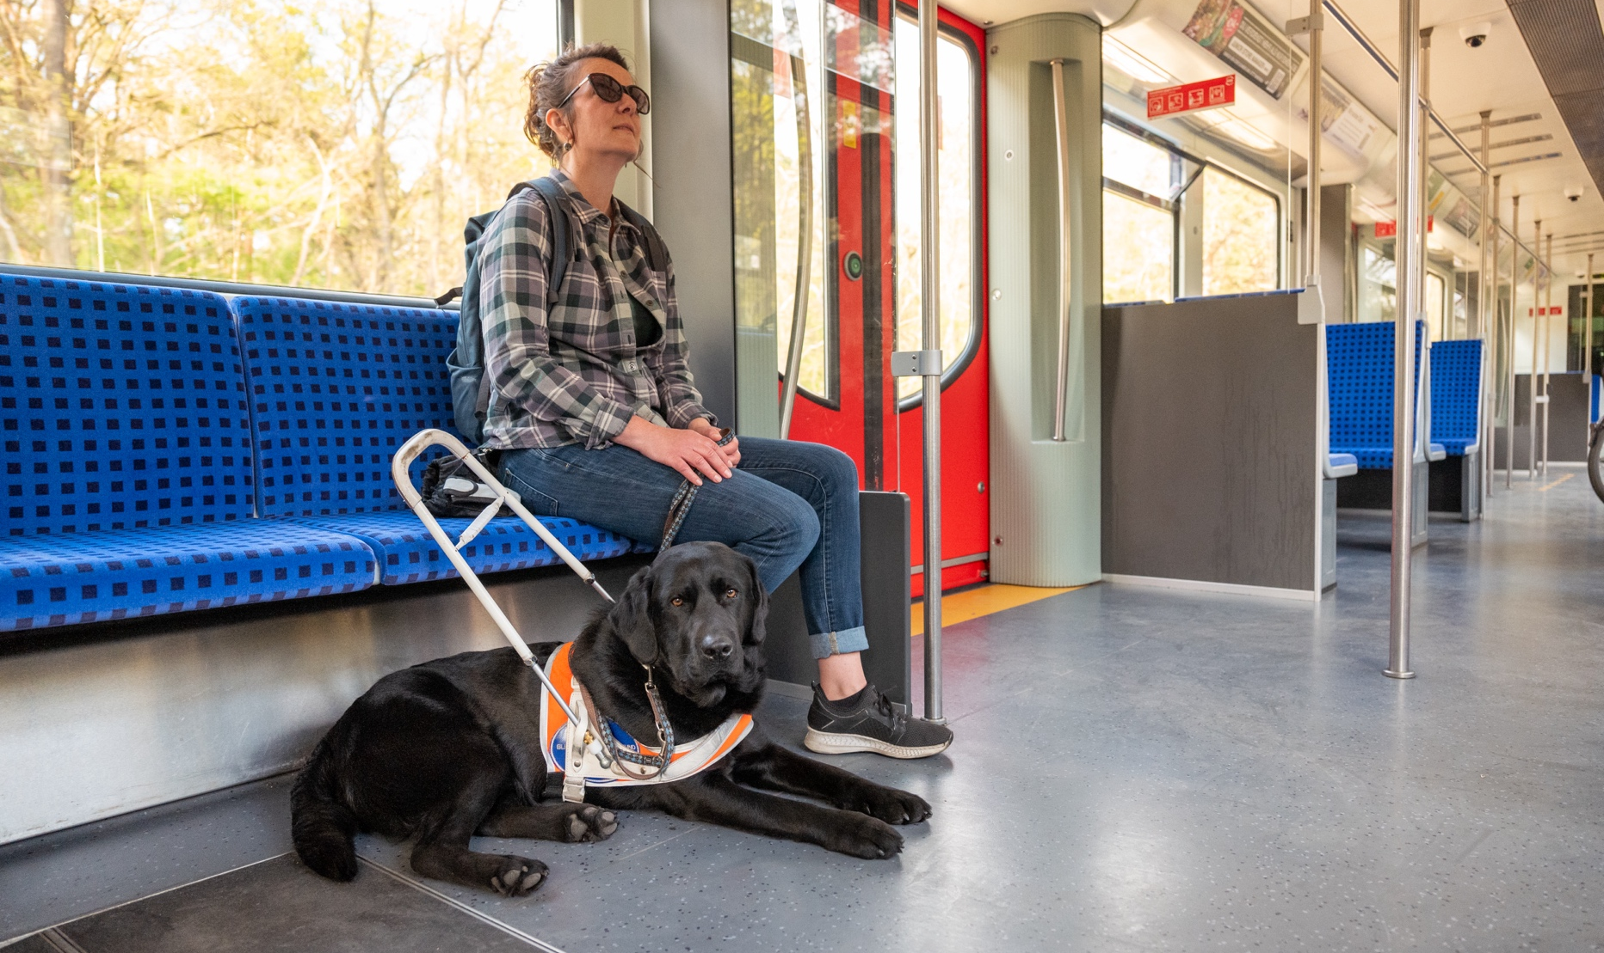
Travelling with an assistance dog
In summary, the Equality Act 2010 describes an assistance dog as a dog:
- trained to guide a blind person;
- trained to assist a deaf person;
- trained by a charity specified in Regulations to assist a person with:
  - Epilepsy;
  - Impaired mobility.
  - Impaired dexterity;
  - Impaired co-ordination; or
  - Impaired ability to lift or move everyday objects.

If you are travelling with an assistance dog, it is helpful that your dog wears its harness or identification jacket. You should also carry your dog’s identification card if you have one.

You can find further information about assistance dogs on the Guide Dogs website.

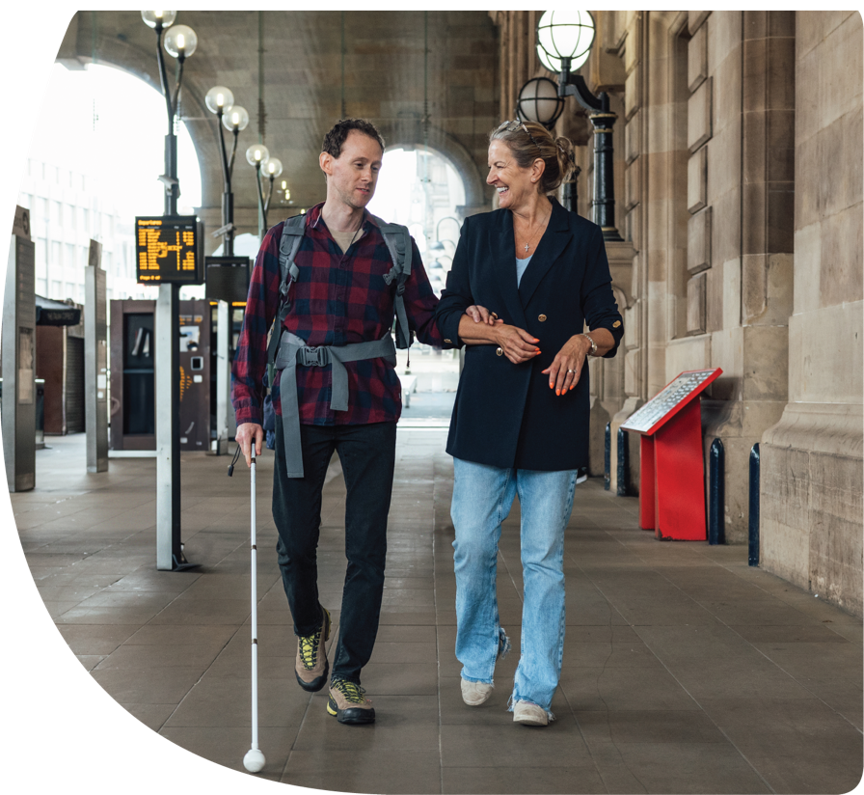
Rail

What if I need assistance when I am travelling on a national rail service and what can I expect in terms of accessibility?
Your train and station operator are required to create and comply with an Accessible Travel Policy (ATP), previously known as Disabled People’s Protection Policies or DPPPs. ATPs are important documents that set out exactly what disabled passengers should expect from their train and station operator. They explain both what you can expect in terms of accessibility and how you can get assistance if you need it.
You will be able to find your operator's ATP on their website, links can be found on the National Rail website.
What does an ATP cover?
- how to book assistance
- help offered to help board and disembark a train
- station facilities
- information on accessibility facilities, connections, delays, disruptions, and emergencies
- tickets and fares
- information points, help points and contact centres
An ATP will tell you if an operator accepts mobility scooters onboard the trains that they operate, and will explain any policy that excludes them. The National Rail Enquiries website also provides information on each operator’s policy.

Passenger Assist
Disabled people can find a lot of useful information on the National Rail Enquiries website. Assistance at all stations is only available during the hours that trains are scheduled to serve the station.
You can also turn up at any station and request assistance onto a train from a member of staff, or via a help point or by a Freephone number. Staff will aim to provide assistance if you do not book in advance, but there may be a delay in providing the required arrangements.
Help is also available through Passenger Assist by phone (0800 022 3720, select option 1) or via the Passenger Assistance App or webform, available on operators’ websites, as well as the National Rail website. You can book your assistance up to 2 hours before your journey and you do not need a railcard.
The app will send your assistance request for each journey to the relevant train operator. The operator will first send an acknowledgement email and then follow up with a confirmation once the request has been checked. Rail staff should then be on hand to deliver the required assistance throughout your journey. If staff are not able to help you straight away, they should explain clearly why not and do their best to assist as soon as they can.

Travelling by rail with an assistance dog
You can travel with your assistance dog and must not be charged for this, nor should there be any cleaning charge. National Rail offers the Assistance Dogs Travel Scheme, supported by Assistance Dogs UK.

Travelling by rail with a wheelchair or a mobility scooter
Trains have mandatory numbers of wheelchair spaces onboard, and where toilets are fitted there must be at least one accessible toilet located next to each wheelchair area. The Passenger Assistance app can be used by wheelchair users to request assistance when using a wheelchair on a train.
There are no mandatory requirements that govern the use of mobility scooters so it may be useful for you to check the ATP of the operator(s) that you intend to travel with in advance of your journey.

How do I claim compensation if my travel has been disrupted or the assistance provided is unsatisfactory or has failed?
If you are not happy with the service provided by your operator, you may be able to claim compensation. For example, if your assistance was booked but was delivered to an unsatisfactory standard, you may be eligible for compensation.
To do this you should contact your operator directly for more information and refer to your train operator’s ATP.
The complaint process does not suspend the statutory period to make a court claim, which varies according to the type of claim. You may wish to seek independent legal advice, if you are not satisfied with the complaints process alone.

How do I complain if my travel has been disrupted or my assistance is unsatisfactory or has failed?
The Office of Rail and Road (ORR) will hold your operator to account on their ATP, and they can review an operator’s policy if they believe that their policy is not being followed.
If you wish to make a complaint because your travel has been disrupted or your assistance is unsatisfactory or has failed, you should contact the train operator in the first instance. If you are unhappy with their final response to your complaint, or if they have not resolved your complaint within 40 working days, you can take your complaint further by contacting the Rail Ombudsman. The Rail Ombudsman will either resolve the issue based on the evidence they receive or, if it falls outside their scope, they will pass it to the body best placed to deal with it, usually the independent watchdogs, Transport Focus or London TravelWatch.

Tips to help you when making a rail complaint
Using your booking reference number, you can contact your operator with the details of your complaint. Your train operator’s website will contain further information and will outline the average response time to resolve your complaint. You can find the contact details of train operators on the National Rail website.

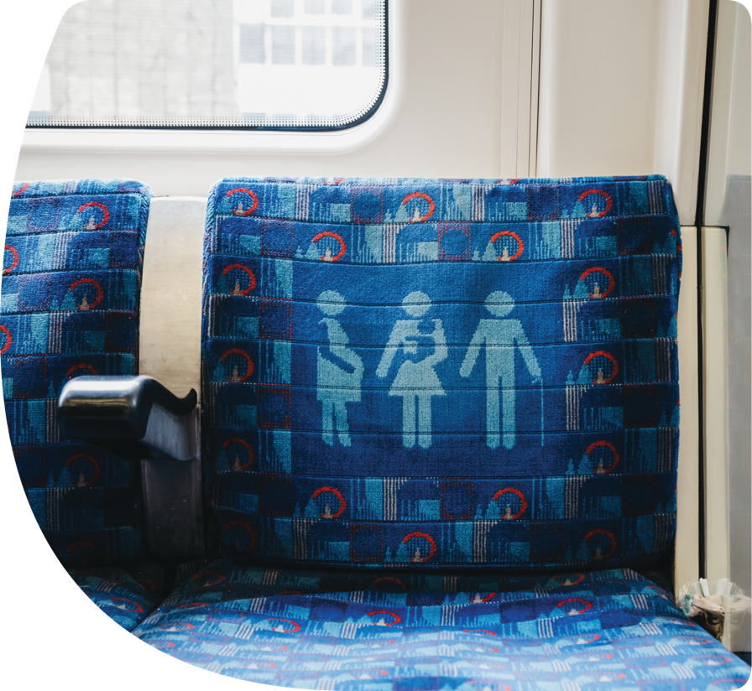
London Underground

What should I do if I need assistance?
On the London Underground and most of the London Overground network, Transport for London (TfL) use a service called "Turn-up-and-go" (TUAG). You do not need to pre-book assistance. You can ask a member of staff to help you board the train or meet you at your destination.
As part of this TUAG service, staff will:
- make you aware if there are unplanned disruptions and suggest alternative step free routes
- come with you from the ticket hall to the platform to help you board the train
- help you get off the train if you are changing stations and help you board the next train
- help you get off the train when you arrive at your final destination on your journey, and accompany you back to the ticket hall
- arrange a boarding ramp, if required (and available)
TfL offer a travel support card which you can order online or download and print at home if you need help communicating any assistance or information requirements. There is space on the card to write down the assistance or information you need and it can be used on any TfL service.

What can I expect in terms of accessibility?
You can find a step-free tube map on the TfL website. However, not all stations are step-free from the platform onto the train. If you require step-free access and your journey starts at or finishes at stations with a manual boarding ramp, or you need to change stations, you will need to find a member of staff at the station before heading to the platform.
More information on accessibility can be found on the TfL website which includes up to date information on stations’ lifts and escalators.
There is also a page called ‘How to Plan an Accessible Journey’ which you may find useful before making your journey.

Travelling with an assistance dog on the London Underground
Assistance dogs are allowed on the London Underground and TfL’s website provides information such as which assistance dogs are allowed to use moving escalators.

Travelling with a wheelchair or a mobility scooter on the London Underground
You can use wheelchairs and some mobility scooters on the London Underground – at TfL's website you can find a step free tube map.

How do I make a complaint if my travel is disrupted or unsatisfactory?
You should contact TfL Accessibility in the first instance. If you are still not happy with the outcome, you can take your complaint further to London TravelWatch or the Local Government Ombudsman (LGO).
London TravelWatch is independent of TfL and can help with complaints about public transport in London.

How do I claim compensation if my travel is disrupted or unsatisfactory?
If assistance has not been provided, TfL will usually offer you a full refund for your journey. They will also coordinate a response to your complaint if your journey has involved more than one train company.
You can claim compensation by contacting TfL Customer Services.

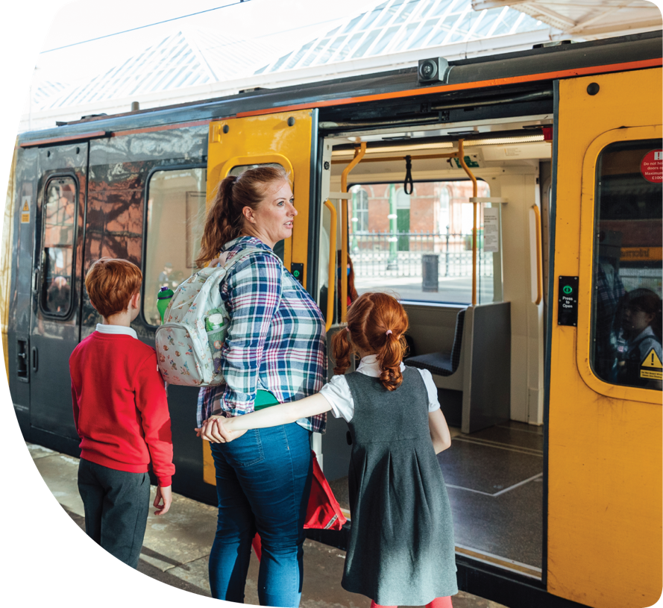
Light Rail (including metros and trams)
Light rail is one of the most accessible modes of public transport.
In England, light rail includes the following tramways and metros:
- Blackpool Trams
- London Trams
- Manchester Metrolink
- Nottingham Express Transit
- Sheffield Supertram
- Tyne and Wear Metro
- West Midland Metro
- Docklands Light Railway (DLR)
Light rail systems in England, outside of London, are compliant with the Equality Act 2010 and are generally fully accessible.
Light rail travel provides passengers with level boarding, step-free or lift access to stations and stops, clear at-stop and on-board passenger information, and vehicle layouts which can accommodate mobility scooters, wheelchairs, and pushchairs.

What if I need assistance?
Many stations/stops do not have staff, although staff should be available to answer calls at all times that services are in operation at the station, as per the guidance provided by the Light Rail Safety and Standards Board. Please check your operator’s website for the number you need to call. It is recommended that you contact at least four hours in advance of your journey.
You can also speak to someone by pressing the buttons if help points are available and the platform is unstaffed. Help points are generally located in the centre of the platform, or on the side of the ticket vending machine and will allow you to speak to a customer service team member.

What can I expect in terms of accessibility?
Almost all light rail vehicles (except older DLR) have the following:
- wheelchair spaces
- passenger information systems
- contrasting floors, handrails and handholds
- tactile and contrasting door controls
- priority seats
The Rail Vehicle Accessibility (Non-Interoperable Rail System) Regulations 2010 (commonly known as RVAR) aim to improve accessibility for disabled people on light rail passenger vehicles. This includes boarding devices, doors, controls, floors, seats, and passenger information. Operators of rail vehicles, under these regulations, must ensure they meet the relevant requirements.
You can find more information about the accessibility of metros and trams by looking at operators’ websites. These should also tell you what to do if you want to make a complaint or claim compensation if your travel has been disrupted or the assistance provided was unsatisfactory.

Travelling with an assistance dog on Light Rail
Assistance dogs are allowed on services, which provide limited space to lie clear of the main passenger route, or under the owner’s seat.

Travelling with a wheelchair or a mobility scooter on Light Rail
Most modern trams are fully accessible for wheelchair users, with step free access and level boarding. There are also designated wheelchair user spaces in each tram, with many having a specially sited intercom to allow passengers in wheelchairs to speak to the driver should they need assistance. Operators will have different policies concerning mobility scooters. You should contact your local operator for more information.

How do I make a complaint if my travel is disrupted or unsatisfactory?
First, you should contact the operator with the details of your complaint. If you are unsatisfied by their response to a complaint, you should contact Transport Focus next, who are an independent watchdog set up by Government who promote the interests of transport users and aim to get the best deal for passengers.
You can also contact London TravelWatch who are the appeals body for complaints made against Transport for London and some rail services. They also work closely with the Rail Ombudsman who handle appeals for most rail companies in the country.

How do I claim compensation if my travel is disrupted or unsatisfactory?

It is recommended that you follow the advice for making a complaint, above.


Bus and Coach

What if I need assistance?
A driver should:
- Stop the vehicle to allow you to board or alight safely. If you need a ramp or lift operating, or for the step height to be reduced, they must arrange this. If you are unable to identify the right bus and signal to the driver yourself, you should ensure that you are clearly visible to approaching vehicles and, where appropriate, seek assistance from other passengers.
- Make reasonable efforts to communicate with you in a way that is accessible to you.
- Ensure that you can access the wheelchair space if you use a wheelchair and the space is available and ensure that you are positioned safely before moving the vehicle. Wheelchair users should be given priority over items like luggage and pushchairs. If there is an item like luggage or a pushchair in the wheelchair space when you try to board the bus, the driver should ask the owner to move this. However, if owners refuse to move the driver cannot force them to do so.
- If required, help you to pay your fare by helping you to get the right change or scan your pass on the ticket machine.
There are also regulations that set out how accessible your local buses and coaches should be. These are known as the Public Service Vehicles Accessibility Regulations 2000 (PSVAR). The regulations state that on buses and coaches:
- There should be lifts or ramps, to enable wheelchair users to board.
- External and internal steps must conform to the requirements of PSVAR, for example the surface of each step tread must be covered in slip-resistant material.
- There must be a pictogram by the door to indicate it is fitted with a ramp or lift.
- There must be slip-resistant flooring.
- There must be route and destination displays on the outside of the vehicle, and colour-contrasting handrails and handholds within.
On buses, there must be a minimum of four priority seats.
More information about PSVAR is available in the guidance that accompanies the legislation.

Travelling on a bus or coach with an assistance dog
PSVAR requires that there must be adequate space under or adjacent to at least one priority seat for the comfortable accommodation of an assistance dog. There are no such requirements for coaches.
There is no limit to the number of assistance dogs on one vehicle, however, drivers may require passengers to move an assistance dog from the gangway, if needed.
It is good practice for bus operators to follow the guidance suggested on the Guide Dogs website, but this is not a legal requirement.

Travelling on a bus or coach with your mobility scooter
There is no requirement for operators to allow disabled passengers to travel with a mobility scooter and those that do so may require passengers to obtain a permit and present it to the bus driver.
The DfT has worked with the Confederation of Passenger Transport (CPT) to create a Code of Practice, for the use and acceptance of mobility scooters on buses, with many operators (but not all) signed up to it.
The Code helps participating operators to identify models of scooter with which their users can safely board, alight and travel on local bus and coach services, and provides guidelines to scooter users on how to do this.
The Code also outlines the acceptable dimensions and weight of your scooter as well as how to apply for a permit if one is required by your operator. Passengers should contact their local operator for further information about mobility scooters on bus services.
Coach operators may accept small lightweight mobility scooters that can be safely stowed in the luggage hold of the coach, if it meets their requirements. Operators recommend that a customer planning to stow a mobility scooter on the coach contacts them in advance of any booking. This will allow them to carry out the required checks.
It is likely that you will be asked the details of the size, make and model of the mobility scooter when booking. Contact details for many coach operators can be found on The Guild of British Coach Operators website.

How do I complain if my bus or coach travel has been disrupted or the assistance provided is unsatisfactory?
If your complaint concerns the driver or the service that they provided to you, it is recommended that you raise a complaint with the operator themselves.
If you are unhappy with the operator response and the issue occurred outside London, you can contact Bus Users UK, an alternative dispute resolution body, to review the matter with your operator. For issues occurring in London, you can contact London TravelWatch.
Complaints regarding a failure to comply with the accessibility standards set out in the PSVAR should be raised directly with the Driver and Vehicle Standards Agency (DVSA). They can be contacted on 0800 030 4103. For more information regarding non-compliance please refer to this guidance on GOV.UK.
If bus stations or stops are inaccessible for you or you have a complaint about concessionary bus passes, you can contact your relevant local authority. Contact details can be found at GOV.UK
Information is also available at: Local Government and Social Care Ombudsman.

How do I claim compensation if my bus or coach travel has been disrupted or the assistance provided is unsatisfactory?
If you want to claim compensation, you should contact the transport operator or authority responsible for service provision in the first instance. If necessary, you can escalate your case to London TravelWatch for travel in London and Bus Users UK outside of London – see complaints (above) for contact details.

Tips to help you when making a complaint

If you, or another person, can write down the vehicle number plate, the name of the bus company, bus route, date, time, and location of where the incident took place to support a complaint, this should assist the investigating and processing of the points you want to raise and potentially reduce your waiting time for response. If you have one, you should also include a photograph of the licence plate if you cannot identify the vehicle.
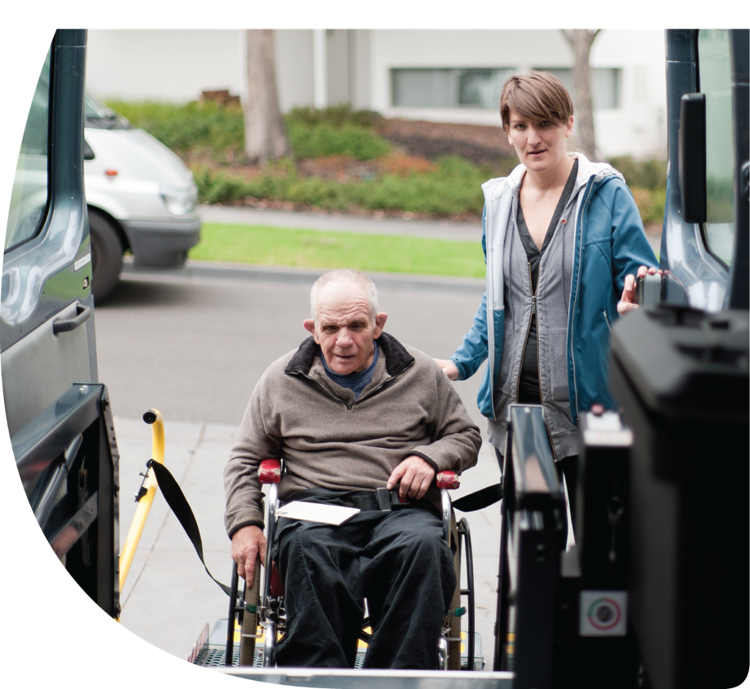

Taxi and Private Hire Vehicle (PHV)
Private Hire Vehicles include the following: minicabs, chauffeurs, executive cars, and limousines. You must book PHV services through a licensed operator; unlike taxis they cannot be hailed on the street.

What if I need assistance?
The Taxi and PHV (Disabled Persons) Act 2022 amended the Equality Act 2010 and set out the assistance a disabled person can expect. It introduced new duties for local licensing authorities, taxi and PHV drivers and PHV operators.
Disabled people should always experience a non-discriminatory journey. This means they receive appropriate assistance, without being charged extra. For example, help with folding away a wheelchair or walking frame, counting out change, or opening a door for a passenger.
PHV operators may ask you if you require assistance when you book. For taxis, this should be when you first contact the driver. A driver should ask passengers what form of assistance you need.
Drivers must provide reasonable mobility assistance unless they are exempt from doing so. However:
- For the exemption to be valid the driver must display the valid local authority issued exemption notice in the windshield of their vehicle.
- An exemption from providing mobility assistance does not exempt drivers from transporting disabled passengers.
A driver who is exempt from providing mobility assistance may not help you with a boarding ramp, help you get in or out of the vehicle, or help fit a seatbelt or wheelchair restraint.
A driver who is exempt from providing mobility assistance, must still accept the carriage of a disabled person:
- If, the passenger can enter and leave the vehicle, including stowing and retrieving any luggage or mobility equipment, without the physical assistance of the driver
- And, provide assistance to identify and find the vehicle they have booked, at no extra charge. This must be requested in advance.

Travelling with an assistance dog
All taxi and PHV drivers must not refuse to carry an assistance dog unless they hold a valid local authority issued exemption certificate, confirming they are exempt for medical reasons. They must also display a valid local authority issued exemption notice in the windscreen of their vehicle.

Travelling with a wheelchair or mobility scooter
Your local authority has a duty to identify and list vehicles which are accessible for wheelchairs.
You should search your local authority’s name alongside ‘wheelchair accessible vehicles’ or contact the authority directly. Your authority will be able to tell you the accessibility of taxis and private hire vehicles in your area.
Not all taxis and PHVs are required to be wheelchair accessible. If a wheelchair accessible vehicle is needed, you may wish to request this in advance.
You can sit in your wheelchair or in a passenger seat. This is dependent on your preference and ability to transfer. It is recommended that where wheelchair accessible vehicles are provided, as a minimum they can carry a person in a “reference wheelchair” (700m in width, 1200mm in length and 1350mm in height). This is the combined height of the wheelchair and the passenger.

There is no set standard for a Wheelchair Accessible Vehicle (WAV). However, they may have the following:
- ramps
- swivel seat
- intermediate step
- seat sight patches
- large, coloured grab handles
- intercom
- induction loop
Many mobility scooters cannot be safely secured in taxis and PHVs, or are too heavy for their ramps. You should check with your taxi or PHV driver, or PHV operator for their policy and size restrictions for mobility scooters.

What if I need to make a complaint about a taxi or PHV driver or a PHV operator?
When using a taxi service, if you need to make a complaint, it is recommended that you raise this with the local licensing authority.
When using the services of a PHV, if you need to make a complaint, it is recommended that you raise this with the operator. If you are dissatisfied with the response or your complaint concerns alleged illegal discrimination, you should escalate it to the relevant local licensing authority.
Taxis and PHVs are licensed by local authorities. This will be your local council (i.e. District or Borough Council or Unitary Authority), or Transport for London, if you live in London.
After this, if you are still dissatisfied with how your complaint has been handled, you can contact the Local Government and Social Care Ombudsman (LGO).

How do I claim compensation if my travel has been disrupted or the assistance provided is unsatisfactory?
The availability of compensation will depend upon the nature of the issue and the policy of the respective local licensing authority or PHV operator. For more information you should contact the relevant authority or operator.

Tips to support you when making a complaint:
- If you can or someone is able to assist you, write down the vehicle number plate or vehicle registration mark. This will usually be on the back of the vehicle.
- Try and find your driver’s licence number, which is located on your driver’s badge.
- If possible, photographs or videos can be taken of the vehicle to help identify it. Sometimes, when booking a taxi or PHV by app the driver’s licence number and vehicle licence plate number will be displayed when you have booked.

Further information

Schemes to help you on public transport
Assistance schemes (such as a card or lanyard) may be run by commercial operators or charities – ask your transport operator directly if they offer a scheme. Many of them do, which can be helpful if you have a less visible impairment that you want to highlight quickly and quietly to transport staff to receive assistance.

Apps and websites to help you with a booking or plan your journey
A range of apps and services are available to support passengers to plan and undertake journeys, some of which may be particularly helpful for disabled passengers. Whilst it is beyond the remit of this guide to recommend specific services, representative organisations and local user groups and operators may be able to assist in identifying them.

Discounts to help you when you travel
- Disabled Persons Railcard
- Disabled Persons Bus Pass
- Jobcentre Plus Travel Discount Card
- London Freedom Pass
- London Taxicard
- Discounted travel for any one registered blind or visually impaired and travelling with a companion
- Transport support services for disabled people

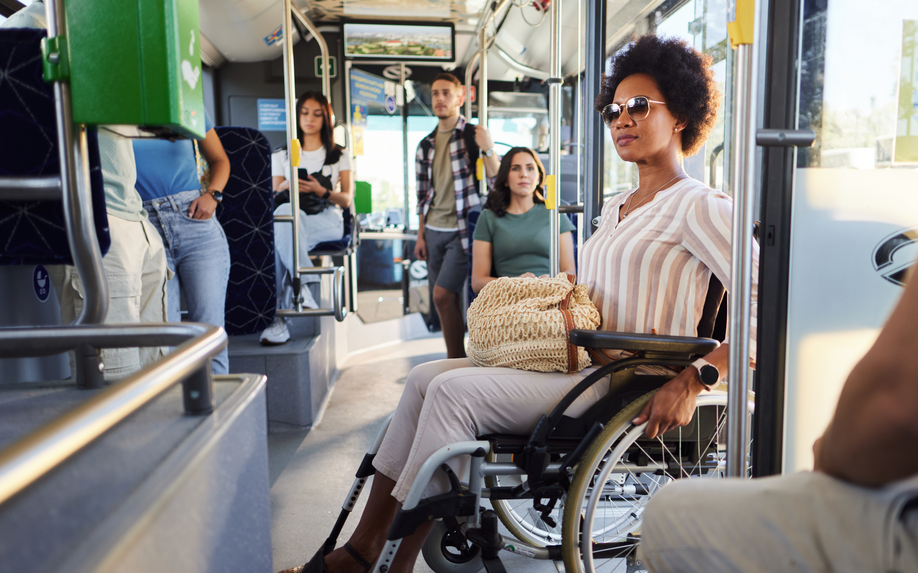
Glossary
Accessible Travel Policy – a document each train operator provides, setting out their commitment to disabled passengers.
Confederation of Passenger Transport (CPT) – a group which represents operators of UK buses and coaches.
Driver and Vehicle Standards Agency (DVSA) – an agency of the Department for Transport, responsible for setting, testing and enforcing driver and vehicle standards in Great Britain.
Light Rail Safety and Standards Board – a central body responsible for safety of trams.
Local Government and Social Care Ombudsman (LGO) – a free service that investigates complaints concerning some public service organisations and decision making processes.
London TravelWatch – an independent watchdog for transport users in London. They are the sister organisation to Transport Focus.
Office of Rail and Road (ORR) – the regulator for Britain’s railways. They oversee your train operators Accessible Travel Policy.
Operator – this means the person or company that runs your service.
Passenger Assistance app - this is a smartphone app and website that can be used to request assistance for future journeys across the National Rail network. It is delivered by Transreport in partnership with National Rail.
Public Service Vehicle Accessibility Regulations – these are vehicle accessibility regulations for bus and coach operators. These are set to ensure that coaches and buses are easily accessible for disabled people.
Rail Ombudsman – an independent organisation offering a free and expert service to help you sort an unresolved complaint about a service you have received.
Taxi and Private Hire Vehicle (Disabled Persons) Act 2022 – a piece of legislation which commenced in 2022. This amended the Equality Act 2022 to place specific duties on drivers, operators and local licensing authorities in relation to disabled passengers.
The Guild of British Coach Operators – an association of top coach companies.
Transport Focus – an independent watchdog for transport users. They are sponsored by the Department for Transport. They can offer you with help and advice with complaints or an issue you feel needs investigating.
Turn up and Go – a service available for passengers who need assistance and have not booked in advance.

Annex A – Complaints process
The individual rights of disabled passengers when travelling, including who to go to when making complaints, are set out at GOV.UK. The diagrams below illustrate the complaints process for each land mode.

Rail
- Want to make a complaint? | - Contact train operating company | - Not satisfied with the response? | - Contact the Rail ombudsman

London Underground
- Want to make a complaint? | - Contact Transport for London | - Not satisfied with the response? | - Contact London TravelWatch or the Local Government Ombudsman

Light Rail
- Want to make a complaint? | - Contact operating company | - Not satisfied with the response? | - Contact London TravelWatch or Transport Focus

Buses and Coaches
Physical accessibility of the vehicle
- Want to make a complaint? | - Contact DVSA
The bus or coach driver
- Want to make a complaint? | - Contact operating company | - Not satisfied with the response? | - Contact Bus Users UK or London TravelWatch if in London

Taxi and Private Hire Vehicles
Driver conduct
- Want to make a complaint? | - Contact relevant local licensing authority
Accessibility of taxi and Private Hire Vehicles in their area
- Want to make a complaint? | - Contact relevant local licensing authority | - Not satisfied with the response? | - Contact the Local Government Ombudsman

